Core Standards and Specifications Vocabulary (CSSV)

v.1.0.0

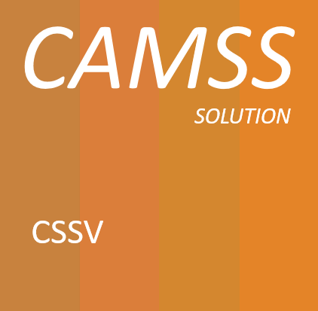

Specification

**Change Control**

|  |  |
| --- | --- |
| **Modification** | **Details** |
| **Version 1.0.0** | |
| **Initial version** |  |

TABLE OF CONTENTS

1. Introduction 6

1.1. Context 6

1.2. The Problem Statement 6

1.3. Scope 7

1.4. Proposed solution 7

1.5. Structure of this document 7

2. Related Solutions 8

2.1. CAMSS Ontology 8

2.2. Core Assessment Vocabulary (CAV) 8

2.3. EIRA Library of Interoperability Specifications (ELIS) 9

2.4. DCAT-AP and ADMS-AP 9

3. CSSV Public Consultation 11

3.1. Promotion Activites 11

3.2. Issues Overview 14

3.3. Metrics 15

4. Core Standards and Specifications Vocabulary 16

4.1. Data Model for the CSSV 16

4.1.1. Interpretation 17

4.2. Class: Specification 19

4.2.1. Property: dct:identifier 19

4.2.2. Property: dct:title 20

4.2.3. Property: dct:alternative 20

4.2.4. Property: dct:description 20

4.2.5. Property: dct:abstract 21

4.2.6. Property: dct:type 21

4.2.7. Property: dct:creator 21

4.2.8. Property: cssv:configuredIn 22

4.2.9. Property: cssv:combinedIn 22

4.3. Class: cssv:Standard 23

4.4. Class: cssv:ApplicationProfile 23

4.4.1. Property: cssv:configures 23

4.5. Class: cssv:Family 24

4.5.1. Property: cssv:combines 24

4.6. Class: cssv:Scope 24

4.6.1. Property: cssv:ID 25

4.6.2. Property: cssv:Description 25

5. Findings and Conclusions 25

6. Conformance statement 26

7. Accessibility and Multilingual Aspects 27

8. Acronyms 27

9. References 28

10. Annex I - Public Consultation Report 28

11. Annex II – CSSV Public Consultation Documentation 28

12. Annex III – CSSV Model 29

Table of Figures

Figure 1: DCAT-AP classes and properties 10

Figure 2: ADMS-AP model 11

Figure 3 News of the CSSV Public Consultation 12

Figure 4 CSSV Public Consultation on Twitter 13

Figure 5 CSSV Public Consultation on LinkedIn 13

Figure 6 Total issues 14

Figure 7 Joinup metrics 15

Figure 8 GitHub metrics 15

Figure 9: CSSV Data model 17

# Introduction

The CSSV is the vocabulary used for the information exchange related to standards and specifications amongst software solutions, as well as, it is the key element for the development of the new release of the EIRA Library of Interoperability Specifications (ELIS). In order to improve the quality of this vocabulary, it has been reviewed publicly through a public consultation[1] where some stakeholders contributed to the improvement of the CSSV.

## Context

The ISA2 Programme of the European Commission supports the development of solutions that enable the cross-border delivery of interoperable public services in Europe. In order to ensure the interoperability of those services, the EIA action works as an integrator between the Member States and other departments of the European Commission for the development of a joint interoperability architecture for public services. The main output of this action is the European Interoperability Reference Architecture (EIRA©[2]).

As an element of EIRA©, the EIRA Library of Interoperability Specifications (ELIS[3]) was created. The ELIS contains the specifications describing the interoperability requirements of the architecture building blocks (ABBs) that conform to EIRA©.

At the core of the ELIS, there is also another asset developed in the context of the CAMSS[4] action that shall be referenced which has been further developed: the **Core Standards and Specifications Vocabulary (CSSV).**

## The Problem Statement

|  |  |
| --- | --- |
| **The problem statement** | At the present stage, there is not a clear definition of what a specification, a standard, a family of specifications and application profiles are. Similarly, it is not clearly expressed how the standards and specifications are related, and what are their purposes and constraints. Moreover discovering and cataloguing interoperability assets – such as EIRA building blocks— with standards and specifications that support their development is currently a hard and time-consuming task. This situation |
| **affects** | all European public administrations, citizens, among others, that need to use specifications or to make reference to them, for the description of specifications in order to facilitate their identification, use, cataloguing and exchange between systems (e.g. ELIS); |
| **the impact of which is** | that the building of electronic catalogues is hampered by problems during the discovery and cataloguing of specifications. This impacts the research of specifications in the catalogue and the users researching specifications. Ultimately, the difficulty in identifying and getting information about the specifications hinders its reuse, the possibility of assessing the conformance of the specifications to regulated purposes and frameworks (scenarios) and, therefore, to formally support other needs and developments. |
| **A successful solution would be** | to come up with a common vocabulary that is able to clearly define the main concepts related to standards and specifications. |

## Scope

The objective of this document is to provide an interoperability oriented solution for the information exchange related to standards and specifications amongst software solutions, the Core Standards and Specifications Vocabulary.

The CSSV specified in this document has been developed taking into account inputs from different sources, namely, the works developed for the ISA2’s CAMSS Action, interested MS, the Semantic Interoperability Community (SEMIC) action of the ISA2 Programme and IT consultants working for the European Commission.

In addition, this vocabulary has been analysed publicly with the objective to get a stable version of the vocabulary which will be used for the development of the new ELIS release. The Public Consultation of the CSSV started on the 24th of October and finalised on the 24th of November. During this period, some change requests have been received and integrated in the CSSV data model, see *4.1 Data Model for the CSSV.*

## Proposed solution

The CSSV defined in this document is based on a preliminary Core Interoperability Standards and Specifications Vocabulary (CISSV) and EIRA CISSV-AP model, which was used for the development of the BETA version of the ELIS in 2018. The CSSV thus replaces that other preliminary model.

## Structure of this document

This document consists of the following sections:

* Section 2 describes the related solutions to the Core Standards and Specifications Vocabulary (CSSV).
* Section 3 contains the report of the Public Consultation of the CSSV.
* Section 4 explains the CSSV model and identifies the classes and properties defined for the vocabulary.
* Section 5 contains the Conformance Statement for this vocabulary.
* Section 6 describes specific accessibility and multilingualism aspects.
* Section 7 lists the different acronyms used in the whole document.
* Section 8 contains related references.

# Related Solutions

This section lists the different related solutions to the CSSV. Note that some of them are still under development.

## CAMSS Ontology

CAMSS stands for Common Assessment Method for Standards and Specifications and it is an action of the ISA2 Programme[5].

The CAMSS Ontology defines the CAMSS terminology and axioms that define the CAMSS concepts and logic rules. The interpretation of the CAMSS concepts cast a clear idea of the method defined in CAMSS to assess standards and specifications.

The CAMSS Ontology is currently under development.

## Core Assessment Vocabulary (CAV)

The Core Assessment Vocabulary represents, expresses and defines what an “Assessment” of “Assets” is and how to perform the assessment based on “Criteria”. It is a domain-agnostic vocabulary, meaning that it can be used to assess any asset. Hence, the CAV is at the very core of the CAMSS Ontology. Or, in other words, the CAMSS Ontology reuses and extends the CAV.

The CAV is also under development. The current CAMSS tool, the CAMSS Ontology, the ELIS, and other projects under development are being used to test and refine the CAV.

## EIRA Library of Interoperability Specifications (ELIS)

The ELIS is a family of interoperability specifications that define the interoperability aspects of the Architecture Building Blocks (ABBs) contained in EIRA©. Its aim is supporting architects for the modelling of solutions based on EIRA©. The current version of ELIS will have to be slightly revamped to accommodate the concepts defined in the CSSV and support the requirement of all the stakeholders, e.g. EIRA-based solution developer needs, NATO profiles, other.

The CSSV is based on the CISSV model, which was used for the development of the BETA version of the ELIS in 2018.

## DCAT-AP and ADMS-AP

The DCAT Application profile for data portals in Europe (DCAT-AP[6]) is a specification based on W3C's Data Catalogue vocabulary (DCAT[7]) for describing public sector datasets in Europe. The Asset Description Metadata Schema (ADMS[8]) in turn was developed as an application profile of the DCAT vocabulary for the description of assets. Hence, DCAT-AP can be used to describe any type of asset (treated as a dataset, especially if you consider that metadata are also data).

The figure below shows the DCAT-AP classes and properties:

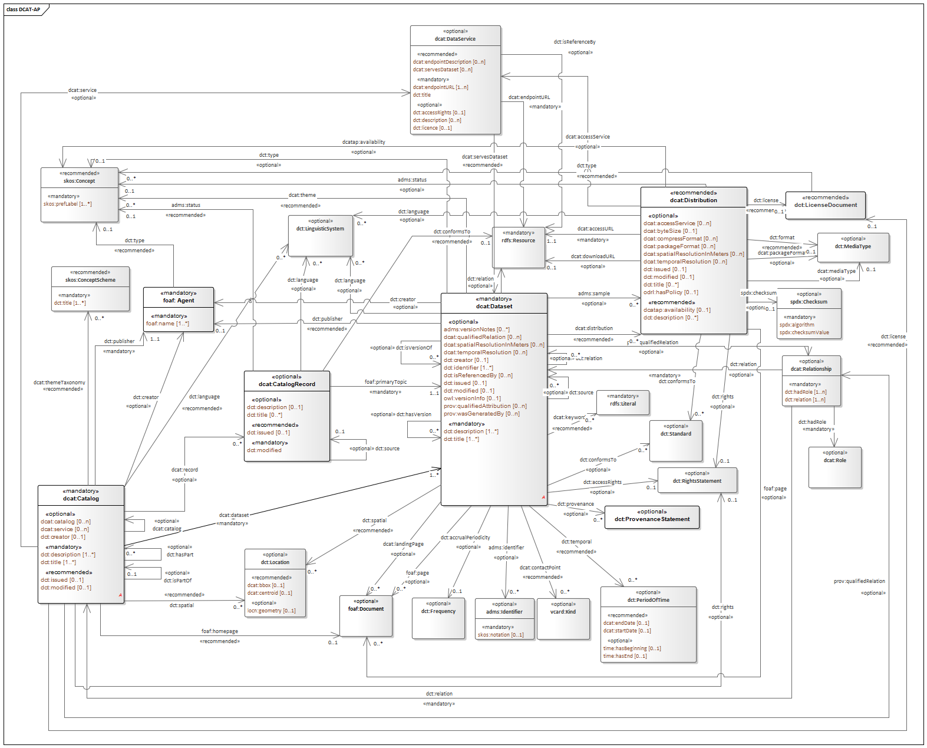

Figure 1: DCAT-AP classes and properties

In the CSSV model, the class Specification can be considered the “root” class and it is an “Asset” as defined in ADMS, which in turn inherits from the *dcat:Dataset class*. The figure below shows how ADMS defines the concept Asset, based on DCAT:

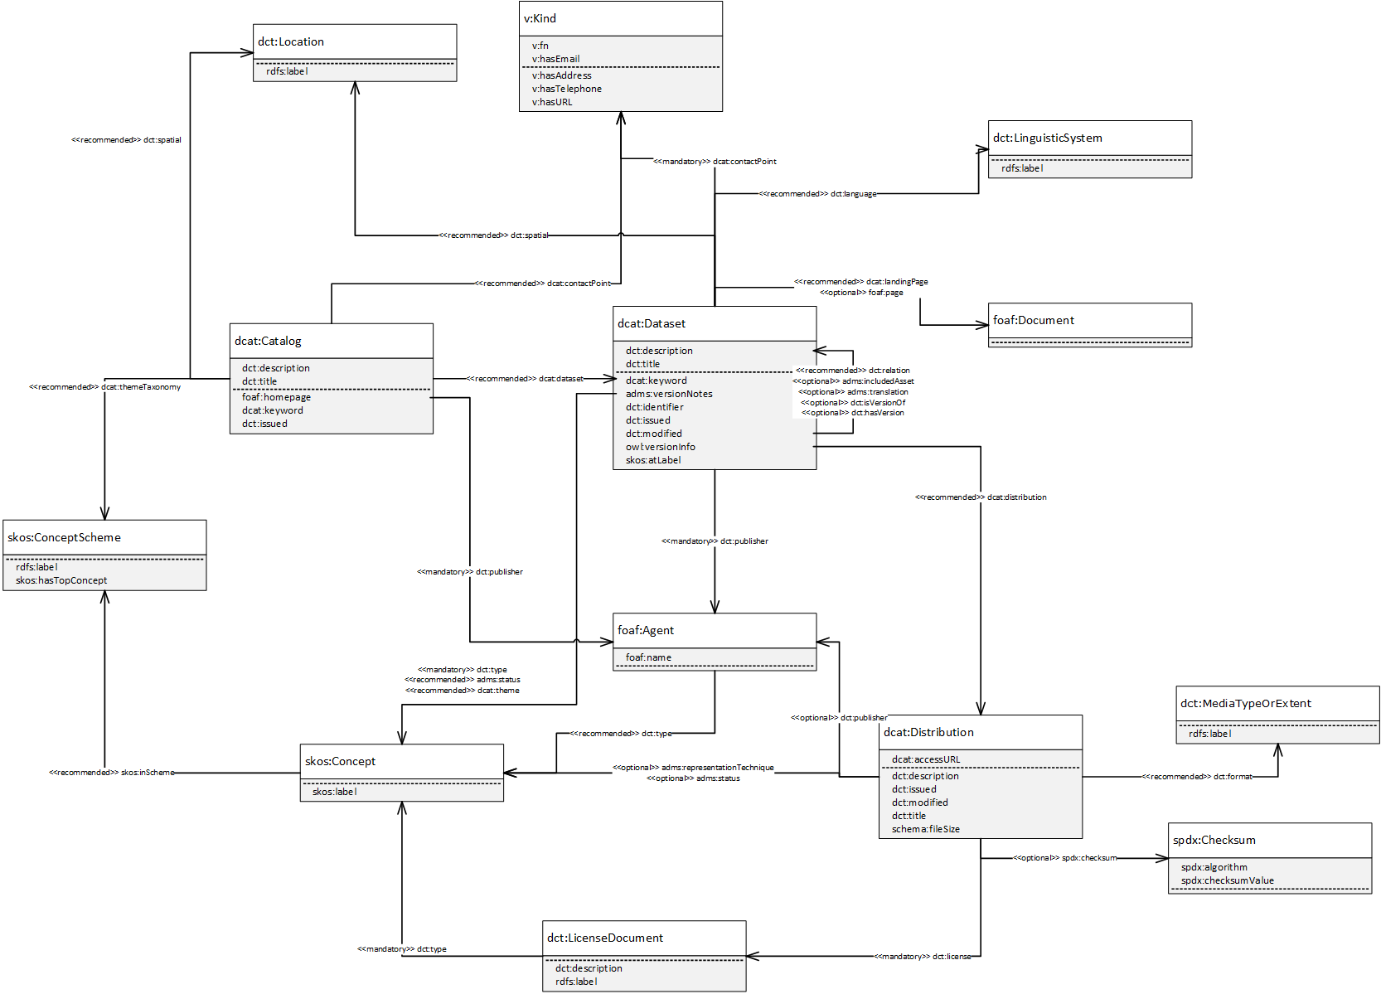

Figure 2: ADMS-AP model

# CSSV Public Consultation

The Public Consultation prepared for the open analysis of the CSSV was carried out through the SEMIC[9] GitHub platform where a repository for the CSSV was created. There, the interested stakeholders submitted their comments creating issues. The Public Consultation started on the 24th of October and finalised on the 24th of November.

## Promotion Activites

The participation of different stakeholders around Europe that could contribute to the improvement of the new vocabulary was one of the main objectives of the Public Consultation. For this purpose, some promotion activities were performed in order to ensure the maximum possible involvement of contributors:

1. **News in Joinup Communities:**

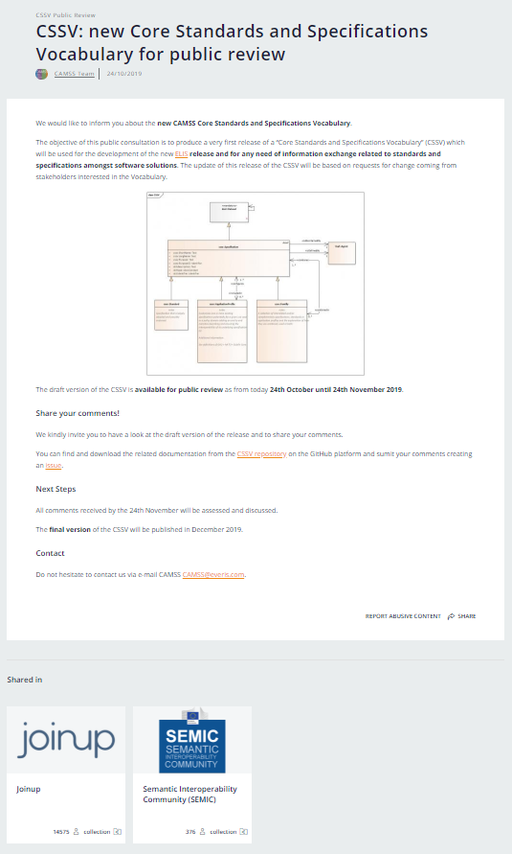

Figure 3 News of the CSSV Public Consultation

1. **ISA2 social media Channels:**

* **Twitter:** <https://twitter.com/EU_ISA2/status/1193933060976320518>

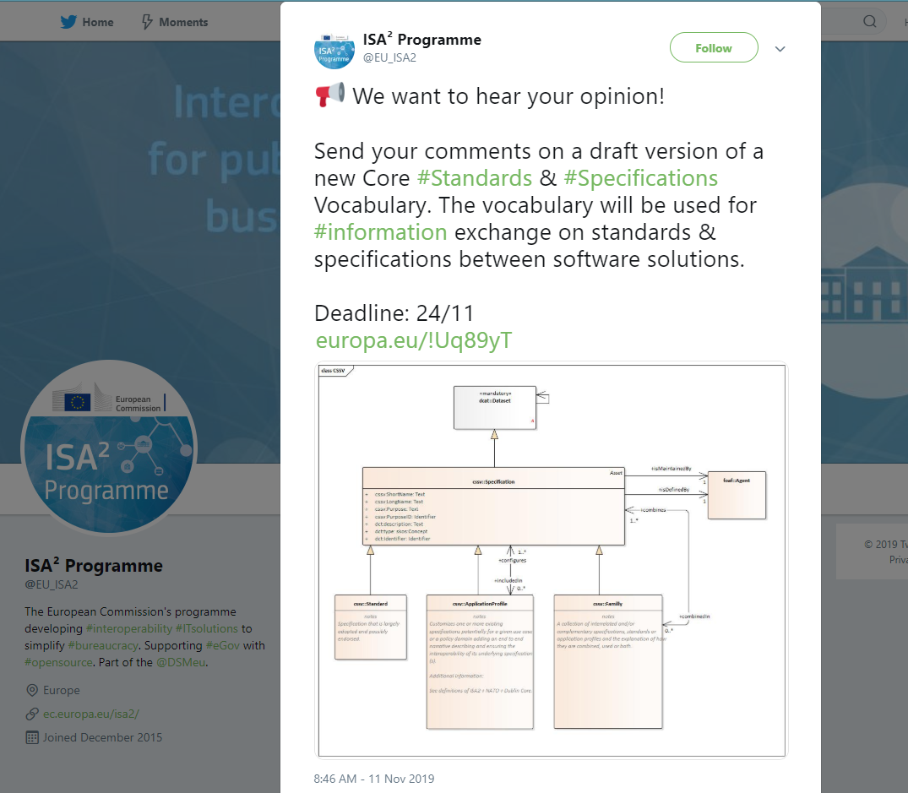

Figure 4 CSSV Public Consultation on Twitter

* **LinkedIn:** <https://www.linkedin.com/posts/isa2programme_interoperability-standards-specifications-activity-6599699860394393600-IyHh>

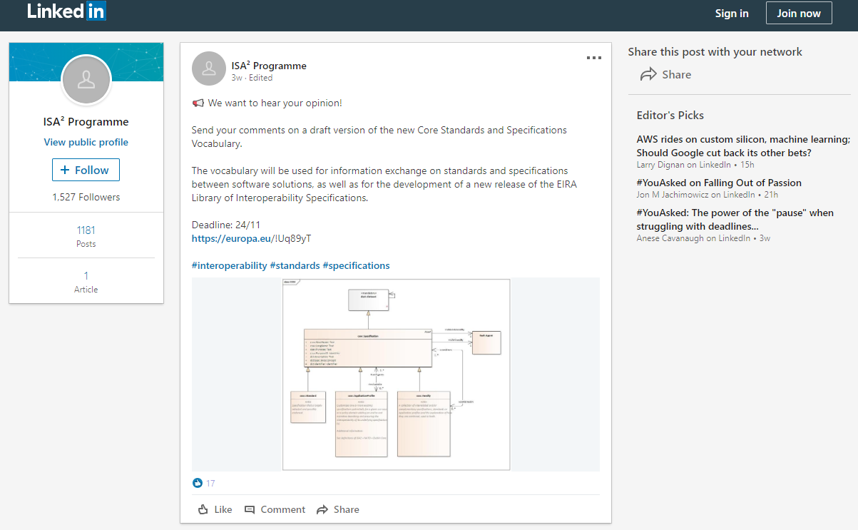

Figure 5 CSSV Public Consultation on LinkedIn

1. **Other promotion activities:**

Additionally to the promotion activities explained above, the CAMSS team informed the experts in charge of the review of the CAMSS Ontology about the CSSV Public Consultation. As well as, the CAMSS Team was in contact with different **SDOs (OASIS[10], W3C****[11] representative members, and MSP****[12])** where the CSSV consultation was promoted. The comments received have been tracked and they will be analysed during the update of the vocabulary. The comments received from the experts can be consulted in *Annex 1 - Public Consultation Report*.

## Issues Overview

A total of 8 issues were received over the 4 weeks consultation period. The picture below shows the issues created in GitHub[13]:

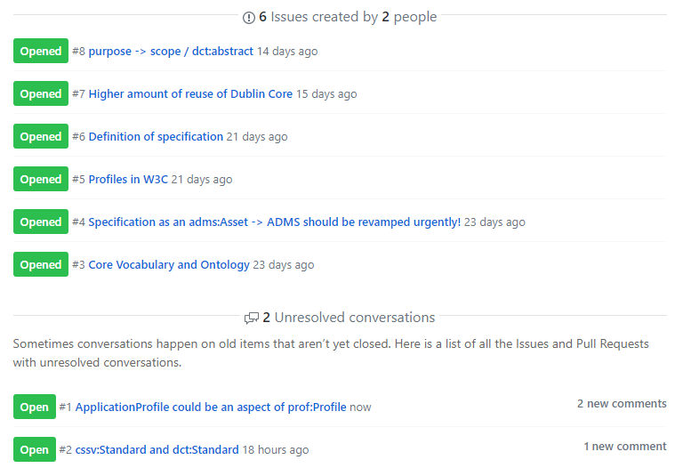

Figure 6 Total issues

These issues have been treated and commented accordingly. These issues have been treated and commented accordingly. The issues received with the CAMSS Teams' replies can be consulted in *Annex 1 - Public Consultation Report*.

## Metrics

This section provides the metrics of the Public Consultation in Joinup and GitHub.

* **Joinup:**

|  |  |  |  |  |  |
| --- | --- | --- | --- | --- | --- |
| **MONTH** | **PAGE URL** | **PAGEVIEWS** | **UNIQUE PAGEVIEWS** | **BOUNCE RATE** | **AVG. TIME ON PAGE** |
| Oct-19 | [collection/common-assessment-method-standards-and-specifications-camss/news/cssv-public-review](https://joinup.ec.europa.eu/collection/common-assessment-method-standards-and-specifications-camss/news/cssv-public-review) | 37 | 23 | 60% | 0:00:54 |
| Nov-19 | 79 | 50 | 42.5% | 0:01:50 |

Figure 7 Joinup metrics

* **GitHub:**

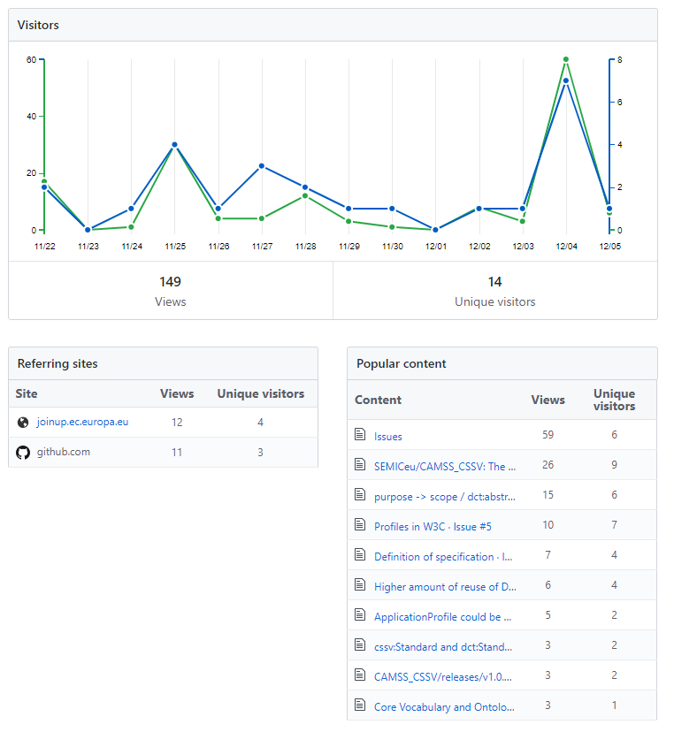

Figure 8 GitHub metrics

# Core Standards and Specifications Vocabulary

The Core Standards and Specifications Vocabulary is depicted in Figure 3 CSSV Data model. The figure shows the classes and properties that are used or defined in the CSSV.

## Data Model for the CSSV

The following data model results from:

* The analysis performed by the CAMSS Team,
* A peer review conducted by a group of five experts working for the European Commission,
* The comments issued by the open community in the public GitHub set up for this public consultation,
* The comments issued by European and international relevant stakeholders, e.g. the MSP and known SDOs11, 12, 13.

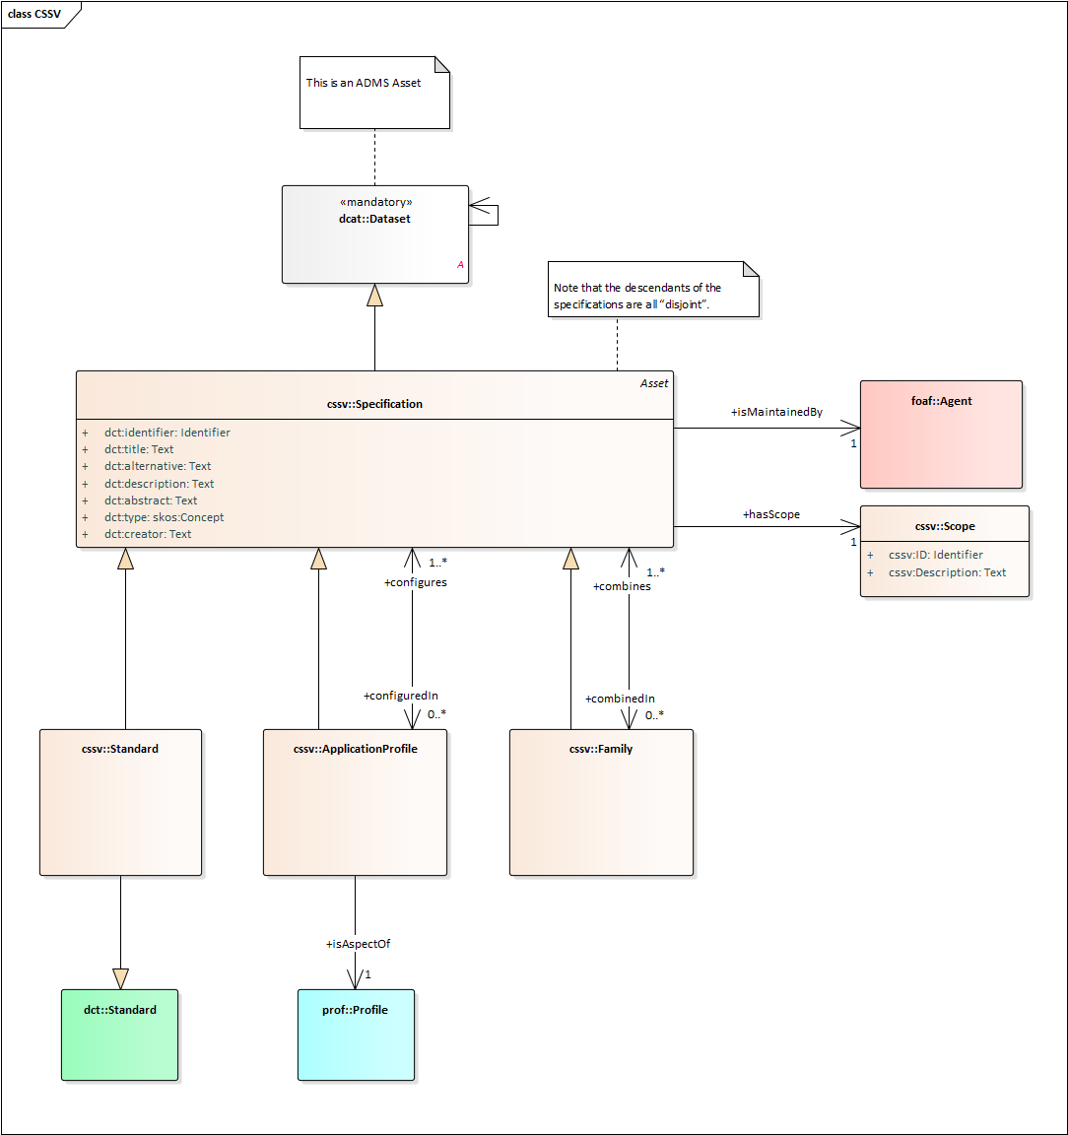

Figure 9: CSSV Data model

### Interpretation

The main class of the CSSV model is the “Specification”. A Specification is an asset, as it inherits from the *dcat:Dataset*, which is the representative of an ADMS Asset.

A Specification, additionally, can be a Standard, an ApplicationProfile and or a Family or a collection of other specifications. The CSSV model defines:

* A **Specification** as a set of agreed, descriptive and normative statements about how a specification should be designed or made.
* A **Standard** as a specification that is largely adopted and possibly endorsed.
* An **ApplicationProfile** as customisation of one or more existing specifications potentially for a given use case or a policy domain adding an end-to-end narrative describing and ensuring the interoperability of its underlying specification(s). By customisation, we understand the “addition of more specificity by identifying mandatory, recommended and optional elements, as well as by defining controlled vocabularies to be employed”.
* A **Family** as a collection of interrelated and/or complementary specifications, standards or application profiles and the explanation of how they are combined, used or both.

A collection of Specifications differs from a Family of Specifications in the fact that the relationship amongst themselves is not explicit. In the CSSV model, a collection of Specifications is an Asset that is related to other Assets and that is realised as an individual of a Specification. In other words, a Specification that reuses the *dct:relation* property of its base class *dcat:Dataset*.

There are occasions where collections of Specifications are applied to a context or a domain in a specific “configuration”. Thus application profiles may conform sets of “themed” specifications. For this, the CSSV model uses the property “configures/includedIn” and the *dcat:theme* property pointing at a *skos:Concept* (i.e. a code, see the DCAT model above).

It is important to note that the descendants of the specifications are all “disjoint”. Thus, ApplicationProfiles and Families are Specifications that refer to or put together with other Specifications and/or Standards, but cannot themselves be considered Standards.

One Specification, in time, may become a Standard. In these cases, the authority (author) that defined the Specification may be different from the one that creates and maintains artefacts out of the Standard. Think for example of the artefacts produced, maintained and distributed by the Publications Office of the European Union (OP) in its site EU Vocabularies[14]: all these artefacts are defined by other authorities (e.g. the ISO), whilst the artefacts (e.g. the controlled vocabularies expressed in SKOS, XML, GeneriCode, XML, etc.) are supplied by the OP. For this, the CSSV uses the properties *dct:creator* and *cssv:isMaintainedBy*. Additionally, the *dcat:Dataset* has the property *dct:type* that can be used to state that the Specification is of type “definition, artefact or other”. The DCAT vocabulary also provides the possibility of expressing who is responsible for the publication of the definition or the artefacts via the property *dct:publisher* (see the ADMS and DCAT models).

The maintainer or publisher of a Specification is a *foaf:Agent*, which allows great flexibility to the CSSV model as *foaf:Agent* is the base class in many ontologies. The CSSV puts forward the reuse of the Core Person Vocabulary (ISA2 CPV) and the Organization Ontology (W3C Org) for this purpose.

In terms of reusability, the class *cssv:Scope* allows the reuse of the Specification. It makes reference to the area of requirements addressed by the specification.

Finally, note that all the descendants of the *ccsv:Specification* are disjoint. This entails that an individual of an application profile or family cannot be a standard, but does not preclude that, in time, the application profile or the family can become standards. If that were the case then individuals of *ccsv:Standard* would be created to represent the standardisation of those specifications that are application profiles and families.

## Class: Specification

|  |  |
| --- | --- |
| OWL Class | cssv:Specification |
| Label: | Specification |
| Definition: | Set of agreed, descriptive and normative statements about how a specification should be designed or made. |
| Subclass of: | dcat:Dataset |

The sections below list the data properties (class attributes) inherited from ADMS that are of particular interest to the class Specification:

### Property: dct:identifier

|  |  |
| --- | --- |
| OWL Property | dct:identifier |
| OWL type: | owl:DataProperty |
| Label: | identifier |
| Definition: | This property contains the main identifier for the specification, e.g. the URI or another unique identifier. |
| Property Type: | xsd:AnyURI |
| Examples: | Any URI pointing at an instance of an Asset. An example of this could be:   * DCAT (W3C) * URI: [http://www.w3.org/ns/dcat#](http://www.w3.org/ns/dcat) * Expression in CSSV:   @prefix cssv: <[http://data.europa.eu/xyz/cssv#](http://data.europa.eu/xyz/cssv)> .  @prefix dct: <<http://purl.org/dc/terms/>> .  <[http://www.w3.org/ns/dcat#](http://www.w3.org/ns/dcat)>        a <cssv:Specification> ;        dct:identifier ”[http://www.w3.org/ns/dcat#](http://www.w3.org/ns/dcat)” . |

### Property: dct:title

|  |  |
| --- | --- |
| OWL Property | dct:title |
| OWL type: | owl:DataProperty |
| Label: | Title |
| Definition: | The name given to the Specification. |
| Property Type: | xsd:String |
| Examples: | Core Standards and Specifications Vocabulary, Core Assessment Vocabulary, Core Public Service Vocabulary, Core Criterion and Core Evidence Vocabulary, etc. |

### Property: dct:alternative

|  |  |
| --- | --- |
| OWL Property | dct:alternative |
| OWL type: | owl:DataProperty |
| Label: | Alternative Title |
| Definition: | The alternative name of the specification. |
| Property Type: | xsd:String |
| Examples: | CSSV, CAV, CPSV, CCCEV, etc. |

### Property: dct:description

|  |  |
| --- | --- |
| OWL Property | dct:description |
| OWL type: | owl:DataProperty |
| Label: | description |
| Definition: | This property contains a free-text account of the Specification. This property can be repeated for parallel language versions of the description. |
| Property Type: | xsd:String |
| Examples: | A free-text account of the Specification. |

### Property: dct:abstract

|  |  |
| --- | --- |
| OWL Property | dct:abstract |
| OWL type: | owl:DataProperty |
| Label: | Abstract |
| Definition: | A summary of the specification. |
| Property Type: | xsd:String |
| Examples: | To define the main concepts and characteristics related to specifications, standards and their combinations and relationships. |

### Property: dct:type

|  |  |
| --- | --- |
| OWL Property | dct:type |
| OWL type: | owl:DataProperty |
| Label: | type |
| Definition: | This property refers to the type of the Specification. A controlled vocabulary for the values has not been defined for the time being. A proposal is provided in the examples below. |
| Property Type: | skos:Concept |
| Examples: | Definition, Artefact, Summary. |

### Property: dct:creator

|  |  |
| --- | --- |
| OWL Property | dct:creator |
| OWL type: | owl:DataProperty |
| Label: | Creator |
| Definition: | The entity primarily responsible for making the specification. |
| Property Type: | xsd:AnyURI |
| Examples: | A creator include a person, an organization, or a service. |

### Property: cssv:configuredIn

|  |  |
| --- | --- |
| OWL Property | cssv:configuredIn |
| OWL type: | owl:ObjectProperty |
| Label: | configuredIn |
| Definition: | A set of Specifications potentially for a given use case or policy domain that are aggregated in an ApplicationProfile. |
| Domain: | *cssv:Specification* |
| Range: | *cssv:ApplicationProfile* |
| Examples: | Instance classes representing application profiles, such as DCAT-AP, ADMS-AP, other. |

### Property: cssv:combinedIn

|  |  |
| --- | --- |
| OWL Property | cssv:combinedIn |
| OWL type: | owl:ObjectProperty |
| Label: | combinedIn |
| Definition: | A set of Specifications that are complementary and interrelated, forming a Family of Specifications. |
| Domain: | *cssv:Specification* |
| Range: | *cssv:Family* |
| Examples: | OASIS UBL XML-based family (XML, XML Schema Definition, ISO Schematron, OASIS Genericode, Context Value Association (CVA), UN/CEFACT unqualified data types); OASIS JSON-based family; CEN TC 440 families; UN/CEFACT CII eInvoice family; other. |

## Class: cssv:Standard

|  |  |
| --- | --- |
| OWL Class | cssv:Standard |
| Label: | Standard |
| Definition: | Specification that is largely adopted and possibly endorsed. |
| Subclass of: | cssv:Specification |

At the present stage all the properties of the *cssv:Standard* class are the ones inherited from *cssv:Specification* and *dcat:Data set.*

## Class: cssv:ApplicationProfile

|  |  |
| --- | --- |
| OWL Class | cssv:ApplicationProfile |
| Label: | Application Profile |
| Definition: | An application profile “customises one or more existing specifications potentially for a given use case or a policy domain adding an end to end narrative describing and ensuring the interoperability of its underlying specification(s)”. |
| Subclass of: | cssv:Specification |

### Property: cssv:configures

|  |  |
| --- | --- |
| OWL Property | cssv:configures |
| OWL type: | owl:ObjectProperty |
| Label: | Configures |
| Definition: | Whether an Application Profile design or adapts a Specification for a specific purpose. |
| Domain: | *cssv:ApplicationProfile* |
| Range: | *cssv:Specification* |
| Examples: | DCAT-AP configuring DCAT for its use in the context of the EU Public Administrations; Any NATO profile configuring a set of interoperability Specifications for a specific context of use; other. |

## Class: cssv:Family

|  |  |
| --- | --- |
| OWL Class | cssv:Family |
| Label: | Family |
| Definition: | A family is a collection of interrelated and/or complementary specifications, standards or application profiles and the explanation of how they are combined, used or both. |
| Subclass of: | cssv:Specification |

### Property: cssv:combines

|  |  |
| --- | --- |
| OWL Property | cssv:combines |
| OWL type: | owl:ObjectProperty |
| Label: | Combines |
| Definition: | Whether a Family is a union of more than one Specifications. |
| Domain: | *cssv:Family* |
| Range: | *cssv:Specification* |
| Examples: | One or more Specifications that are part of a family, e.g. OASIS UBL XML-based family (XML, XML Schema Definition, ISO Schematron, OASIS Genericode, Context Value Association (CVA), UN/CEFACT unqualified data types); OASIS JSON-based family; CEN TC 440 families; UN/CEFACT CII eInvoice family; other. Conformance Statement. |

## Class: cssv:Scope

|  |  |
| --- | --- |
| OWL Class | cssv:Scope |
| Label: | Scope |
| Definition: | Area of requirements addressed by the specification. |

### Property: cssv:ID

|  |  |
| --- | --- |
| OWL Property | cssv:ID |
| OWL type: | owl:DataProperty |
| Label: | identifier |
| Definition: | This property contains the main identifier for the scope, e.g. the URI or another unique identifier. |
| Property Type: | xsd:AnyURI |
| Examples: | Any URI pointing at an instance of the Scope. |

### Property: cssv:Description

|  |  |
| --- | --- |
| OWL Property | cssv:Description |
| OWL type: | owl:DataProperty |
| Label: | description |
| Definition: | This property contains a free-text account of the Scope. This property can be repeated for parallel language versions of the description. |
| Property Type: | xsd:String |
| Examples: | A free-text account of the Scope. |

# Findings and Conclusions

The public consultation has produced some findings and relevant conclusions:

1. **Finding #1**: a data model, vocabulary or ontology tackling the domain of standards and specifications was not found. However two recent initiatives are to be mentioned:
   1. NISO recently voted a new project[15] to create a Standards-Specific Ontology Standard (short title: NISO SSOS). A working group is in the process of being formed to develop and standardize a high-level ontology to describe a limited set of core concepts and relationships.
   2. W3C has developed “The Profiles Vocabulary”, an RDF vocabulary to describe profiles of (one or more) standards for information resources. It describes the general pattern of narrowing the scope of a specification with additional, but consistent, constraints, and is particularly relevant to data exchange situations where conformance to such profiles is expected and carries additional context.
2. **Conclusion related to Finding #1**: The CAMSS CSSV development team should contact these two initiatives and examine how synergies and collaboration could be established from now on. Additionally the CAMSS Team should invite them to participate actively in the evolution of the CSSV via the governance and maintenance mechanisms put forward by ISA2.
3. **Finding #2**: The CAMSS Teams and the ISA2 Communications Team performed a proper dissemination of the public consultation. However the feedback provided by the community and contacted stakeholders has produced very few feed-back with no major impacts on the proposed data model.
4. **Conclusion related to Finding #2**: The community has not have the opportunity of applying the model to actual Use Cases and the comments received are based on the reading of the conceptual model and its related documentation. Proof of concepts and pilots should be proposed for multiple different business and problem domains in order to challenge the vocabulary.

# Conformance statement

A data interchange of Standards or Specifications, however that interchange occurs, is conformant with the CSSV if:

* it uses the terms (classes and properties) in a way consistent with their semantics as declared in this specification;
* it does not use terms from other vocabularies instead of ones defined in this vocabulary that could reasonably be used.

A conforming data interchange:

* may include terms from other vocabularies;
* may use only a subset of CSSV terms.

The CSSV is technology-neutral and a publisher may use any of the terms defined in this document encoded in any technology although RDF and XML are preferred.

# Accessibility and Multilingual Aspects

The CSSV can operate in any language as:

* In a multilingual context, all those properties that are datatype “Text” the value may exist in multiple languages, the property may be instantiated multiple times and tagged with the language identifier for the value used for that property.
* The CSSV specification encourages the use of PURIs as identifiers.

The labels used can be translated and added to the schema (please contact the working group if you can help with this).

# Acronyms

|  |  |
| --- | --- |
| Term | Description |
| EIRA© | European Interoperability Reference Architecture |
| ELIS | EIRA Library of Interoperability Specifications |
| ABBs | Architecture Building Blocks |
| CSSV | Core Standards and Specifications Vocabulary |
| SEMIC | Semantic Interoperability Community |
| CISSV | Core Interoperability Standards and Specifications Vocabulary |
| EIRA CISSV-AP | EIRA Core Interoperability Standards and Specifications Vocabulary Application Profile |
| CAV | Core Assessment Vocabulary |
| DCAT | Data Catalogue Vocabulary |
| DCAT-AP | Data Catalogue Vocabulary Application Profile |
| ADMS | The Asset Description Metadata Schema |
| CPSV | Core Public Service Vocabulary |

# References

*ADMS* . (n.d.). Retrieved from https://joinup.ec.europa.eu/collection/semantic-interoperability-community-semic/adms

*CAMSS - Common Assessment Method for Standards and Specifications*. (n.d.). Retrieved from https://joinup.ec.europa.eu/collection/common-assessment-method-standards-and-specifications-camss/about

*DCAT-AP v1.1.* . (n.d.). Retrieved from https://joinup.ec.europa.eu/release/dcat-ap-v11

*EIRA - European Interoperability Reference Architecture*. (n.d.). Retrieved from https://joinup.ec.europa.eu/collection/european-interoperability-reference-architecture-eira/about

*ELIS - EIRA Library of Interoperability Specifications*. (n.d.). Retrieved from https://joinup.ec.europa.eu/release/eira-library-interoperability-specifications-elis/v100-beta

*ESCO Taxonomy*. (n.d.). Retrieved from https://ec.europa.eu/esco/portal/occupation

*EU Vocabularies*. (n.d.). Retrieved from https://publications.europa.eu/en/web/eu-vocabularies/controlled-vocabularies

*W3C*. (2019, October 03). Retrieved from Data Catalog Vocabulary (DCAT): https://www.w3.org/TR/vocab-dcat/

# Annex I - Public Consultation Report



# Annex II – CSSV Public Consultation Documentation

<https://github.com/SEMICeu/CAMSS_CSSV/tree/master/releases/v1.0.0>

# Annex III – CSSV Model

[](CSSV%20v1.0.0.xml)[](CSSV%20v1.0.0.eap)[](CSSV%20v1.0.0.jpg)

1. CSSV Public Consultation: <https://github.com/SEMICeu/CAMSS_CSSV>
2. EIRA: <https://joinup.ec.europa.eu/collection/european-interoperability-reference-architecture-eira/about>
3. ELIS: <https://joinup.ec.europa.eu/release/eira-library-interoperability-specifications-elis/v100-beta>
4. CAMSS: <https://joinup.ec.europa.eu/collection/common-assessment-method-standards-and-specifications-camss/about>
5. Achieving a modern standard ICT standardisation policy; CAMSS Action 2016.27: <https://ec.europa.eu/isa2/actions/achieving-modern-ict-standardisation-policy_en>.
6. DCAT-AP: <https://joinup.ec.europa.eu/solution/dcat-application-profile-data-portals-europe/release/200>
7. W3C DCAT specification: <https://www.w3.org/TR/vocab-dcat/>
8. ADMS: <https://joinup.ec.europa.eu/collection/semantic-interoperability-community-semic/adms>
9. GitHub of SEMIC: <https://github.com/SEMICeu>
10. OASIS Webpage: <https://www.oasis-open.org/>
11. W3C Webpage: <https://www.w3.org/>
12. European Multi Stakeholder Platform on ICT Standardisation: <https://ec.europa.eu/digital-single-market/en/european-multi-stakeholder-platform-ict-standardisation>
13. CSSV Public Consultation issues: <https://github.com/SEMICeu/CAMSS_CSSV/issues>
14. EU Vocabularies: <https://publications.europa.eu/en/web/eu-vocabularies/controlled-vocabularies>
15. NISO-SSOS: <https://www.niso.org/niso-io/2019/11/wgc-new#ssos>.